


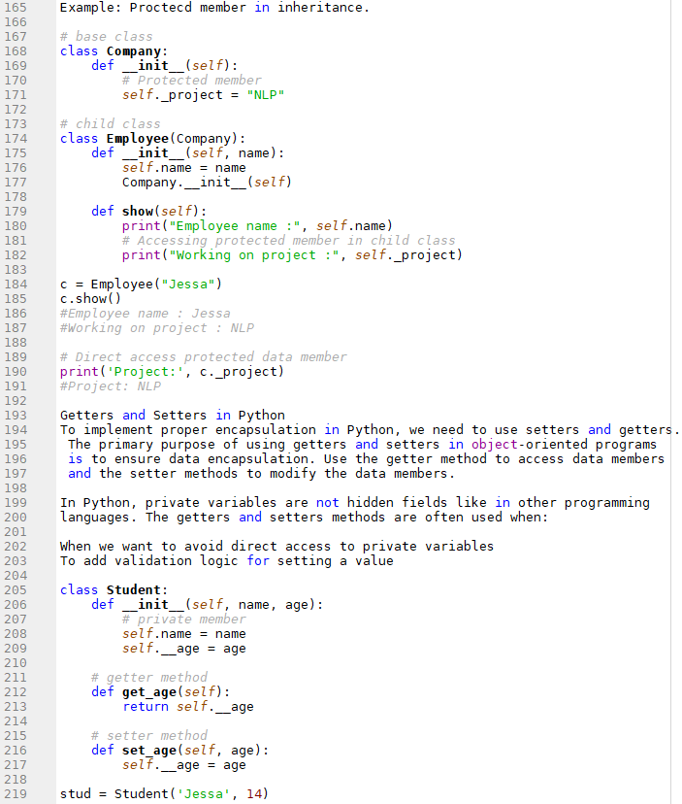

Advantages of Encapsulation
Security: The main advantage of using encapsulation is the security of the data.
Encapsulation protects an object from unauthorized access. It allows private
and protected access levels to prevent accidental data modification.
Data Hiding: The user would not be knowing what is going on behind the scene.
They would only be knowing that to modify a data member, call the setter method.
To read a data member, call the getter method. What these setter and getter
methods are doing is hidden from them.
Simplicity: It simplifies the maintenance of the application by keeping classes
separated and preventing them from tightly coupling with each other.
Aesthetics: Bundling data and methods within a class makes code more readable
and maintainable

